Career Guidance & Counselling

The youth, school leavers in particular, with secondary education background, need to undergo vocational training (VT) before entering the World of Work. (WW) With ever changing needs of the WW blended with diversified desires of youth, the youth need guidance in the selection of a field/ occupation for their training in vocational training.

NAITA currently provides this Career Guidance & CounsellingÂ  in an effective manner together with awareness on available career laddering paths.. The CG & C, Section, together with its centres provides CG & C services to around 30,000 youth annually.

The activities performed by the unit are;

* Conducting group awareness programs on Career Guidance and counselling for school attending students / school leavers and other identified categories of youth.
* Highlighting Vocational and Technical Training and Labour Market demands during Career Guidance Sessions.
* Conducting individual Career Guidance and counselling.

To Conduct a Career Guidance and Counselling Programme in your school or organization please Contact:

**Training Manager,**  
Career Guidance and Counselling Section,  
NAITA,  
No.971, Sri Jayawardenapura Mawatha,  
Welikada,  
Rajagiriya.

**Committee on Equating and / or Validating Certificate, Diploma and Degrees (CEVCD)**  
  
NAITA has fully power and authority to equalize and / or validate to the local and foreign Certificates, Diplomas and Degrees under the section of 37(a) of the Tertiary and Vocational Education Act No. 20 of 1990.  
  
CEVCD as for as practicable shall comply and confirm to the requirements stipulated in the Sri Lankan National Vocational Qualification (NVQ) framework already developed by the Tertiary and Vocational Education Commission (TVEC) for the courses leading to the award of certificates in TVET in evaluating qualifications referred.  
  
As the NVQ System has not been fully developed to embrace entire range of Certificates, Diplomas and Degrees, the CEVCD shall consider any such Qualification on a case by case basis making use of existing practices both locally and internationally.

The National Vocational Qualifications (NVQ) framework is a seven level qualification system. Figure 01 – Illustrates the National Vocational Qualifications (NVQ) Framework.

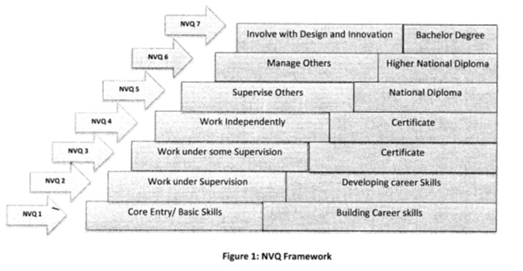

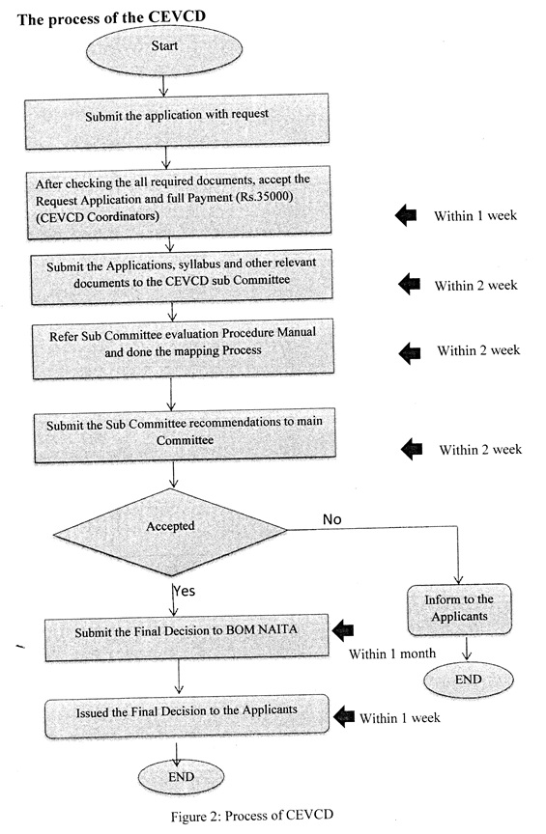

Mainly CEVCD should responsible to evaluate the individual requests by applicants. Total hours of this process 12 weeks. CEVCD can map the individual courses to NVQ or Non NVQ.  
  
Information required for the process of Equating and or Validating of Certificates, Diplomas and Degrees,

- Certified copy of course certificate  
- Entry qualifications  
- Durations (Part Time / Full Time)  
- Transcript  
- Course curriculum together with details syllabi  
- Laboratory and work shop facilities  
- On the job training work experience (supervised training)

Evaluation of Course curriculum – Calculation of credit values

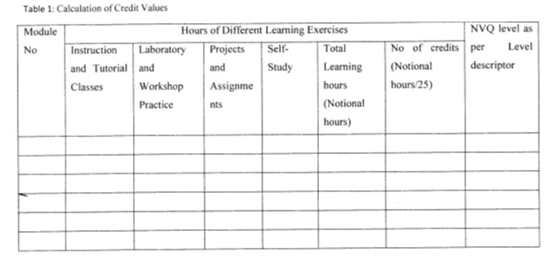

The credit system of National Vocational Qualification

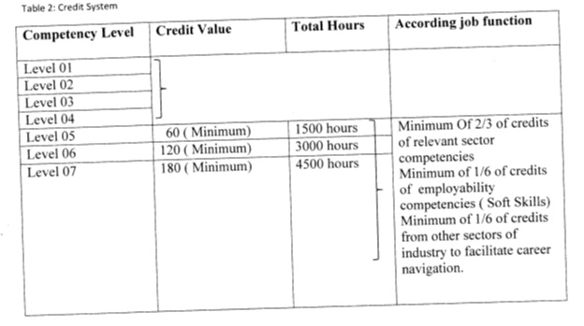

1. Meeting Date for CEVCD applicants — Wednesdays Only (Government public day).

2. The initial conditions

a. CEVCD process only responsible to evaluate the individual requests by applicants.(course or Institutions will not be evaluated)

b. For NVQ Level 5 - Applicant should complete 1500 hours course with minimum 60 Credits. (1 Credit = 25 Notional hours)

c. For NVQ Level 6 - Applicant should complete 3000 hours course with minimum 120 Credits. (1 Credit = 25 Notional hours)

d. Craft level certificates will not be mapped to NVQ level

3. Information to be required from applicant

a. Copy of course certificate certified by JP or the institute

b. Detailed Syllabus of the respective year (including number of teaching learning hours & number of credits) certified by the institute

c. Course Transcript Certified by the institute

4. Payment Procedure

a. 1st Installment (Initial payment for screening certificates) — Rs. 7,500 /= (Non-Refundable.

b. 2nd Installment (Final payment to equate the certificate) — Rs.27,500/= (Collected only after the evaluation of applicant’s qualification)

5. Application submission period

a. 1st evaluation (March) – 1st of October to 31st of January

b. 2nd evaluation (July) — 1st of February to 31st of May

c. 3rd evaluation (November) — 1st of June to 30th of September

**In 2020 process was delayed due to COVID 19 epidemic. New Application submission start on 1st of September 2020 to 16th of October 2020**

|  |  |  |
| --- | --- | --- |
| **Tel No** | : | +94 11 2888782-5 |
| **Fax No** | : | +94 11 2863737 |

**English Language Skills Training (CELV)**

**Introduction:**  
Language Skills Training Unit of National Apprentice & Industrial Training Authority is responsible mainly to conduct vocational English classes for apprentices who are undergoing training in various fields.  
  
**Certificate in English for Living and vocations (CELV)**  
In addition to the above functions, we have introduced "**CERTIFICATE IN ENGLISH FOR LIVING AND VOCATIONS (CELV)"**. Fee-Levying English Programme recently.  
  
This is conducted throughout the island in our training centers. This programme has been specially designed to cater to the students who are G.C.E. (O/L) and A/L qualified. They lack the required English language Skills to acquire the knowledge in different fields.  
  
**"CELV" English Programme:**

* Duration :- 200 hours (Approximately 8 months)
* Course Fee :- Rs.4000/- + Registration Fee - Rs.100 (Subject to change)
* Classes are conducted on Saturday s/Sundays or Weekdays.
* Participants can select either Weekend or Weekday classes.
* Final assessment consists of a written test and an oral test.
* A well recognized NAITA certificate will be awarded for those who complete the course successfully.

**For further details :**  
Language Skills Unit,  
NAITA, No.971, Sri Jayawardenapura Mawatha,  
Welikada, Rajagiriya.  
Tele : 011 2888782-7  
Fax : 2863737  
  
Or  
  
[Contact District Managers at District Offices.](http://www.naita.gov.lk/index.php?option=com_content&view=article&id=64&Itemid=87&lang=en)

[Download Application Form](http://www.naita.gov.lk/images/stories/mod/pdf/celve001.pdf)

Last Updated on Wednesday, 10 July 2013 10:38

## Entrepreneurship Development

#### **Introduction:**

SME sector has become more active and plays a very important role in society. The Government also encourages to develop and make a strong SME sector in Sri Lanka by giving various promotions. On the other hand SME can create higher volume of jobs opportunities than usual formal organizations can. Presently more and more young men and women try to start their own businesses rather than working under someone.

NAITA is one of the leading vocational training providers in Sri Lanka and provides employable skills to the youth through the apprenticeship training system. Therefore all trainees trained in NAITA fully or partially gain their training in a work environment or business environment. This feature would be very much favourable for them to manage small enterprises/businesses at the end of their training. An entrepreneurial skill helps a person to make his/ her career a success.

Having identified the importance of Entrepreneurship, NAITA has established a division to work on this.

#### **Funtions:**

* Conducting Entrepreneurship Awareness programmes for diplomates.
* Conducting Entrepreneurship Development programmes varying from 5 days to 14 days.
* Implementing Know About Business (KAB) training programmes for apprentices with coordination of the SIYB association of Sri Lanka.
* This ED section of NAITA conducts tailor made programmes for NGOâ€™s and other community development agencies.

#### **Course Contents for Entrepreneurship Development Programme:**

* Personnel Entrepreneurship Competencies
* Business Environment
* Goal Setting
* Resource Identification
* Business Idea Generation
* Business Idea Screening
* Bank Evaluation of Business Plan
* Business Plan Preparation
* Business Idea Selection

#### **Subject areas covered at Know About Business (KAB) Programmes:**

* What is Enterprise
* Why Entrepreneurship
* Who are Entrepreneurs
* How do I Become an Entrepreneur
* How do I Organize an Enterprise
* How do I operate an Enterprise
* What are the steps to become an Entrepreneur

More than 50 Master Trainers are there all over the country to conduct these programmes in Sinhala and Tamil medium.

#### **For more details Please contact:**

**Training Officer**  
Enterprenurship Development Division  
NAITA,  
No. 971, Sri Jayawardenapura Mawatha,  
Welikada,  
Rajagiriya.  
  
Tel. 0112 888782-7

## Special Industrial Training

#### **Introduction**

The National Apprentice and Industrial Training Authority, (NAITA) in its efforts to enhance the National Economy through a wide range of activities aimed in particular at youth skill development, takes on the challenge of human resource development in the country. NAITA recognizes the possible avenues of skill development, and the occupations so identified for skill development are grouped, or in it's terminology, "categorized" based on the educational achievements required. Thus, Industrial Training provided to Universities and Training Institutions by placing the students in the Industrial environment enable them to apply disciplines learned to gain practical experience, sound appreciation and understanding of the theoretical principles in work stations/ sites. This function is carried out by the Special Industrial Training Section (SIT).

#### **Role of the Industry**

The industries make provision for these trainees to receive training as far as possible in keeping with the relevant Training Standard/Training Schedule The training would be supervised by a senior officer or a qualified Engineer, who may have been assigned for this purpose. These officers guide the trainees in maintaining their log books(Daily Diaries}, writing intermittent reports and assisting in making up a considerable coverage of their training.

#### **In - Plant Training of Undergraduate and Diploma Students of Universities**

The In-Plant training is a supplementary component to the courses conducted by the Universities of Moratuwa and Peradeniya for the Engineering Degree and Information Technology students, National Diploma In Technology(NDT) students of Institute of Technologies, University of Moratuwa. and also to the NDT Agriculture students of Hardy Advanced Technological Institute, Ampari.

The Authority is also providing internship for the first time to the Micro Biology, Biological Science and Zoological Science students of Kelaniya University and the Applied Science students of the Wayamba University. . Refer the table given below for more details.

All trainees of the above institutions are placed in the industry relevant to their disciplines of study and subjected to interim and final assessments. The results of the successful trainees are forwarded to the Institutions for them to become qualified for the award of the Degree or Diploma Certificates.

Industrial Training of Higher National Diploma (HND) students of Advanced Technical Institutes.

The industrial training part of HND students is provided by our authority and there results are notified to the respective Institutions as in the above case for them to become eligible for their certificates. Refer the table given below for more details.

#### **National Certificate for Industrial Technician(NCIT) students of the Technical Colleges, Maradana and Ratmalana**

NCIT students of the above institutions too are provided industrial Training and their results are notified for them to be eligible for their Certificate . Refer the table given below for more details.

#### **Monitoring of Training**

All trainees are expected to sign the contract of apprenticeship, and will be called an "Apprentice" in general irrespective of the academic background Monitoring is carried out for the purpose of eliminating possible shortcomings and thus backing up the trainees to get a successful industrial experience.

Apart from the industry personnel and NAITA staff, Training engineers of the respective universities/institutions along with the academic staff of the respective departments are expected to attend to this activity.

#### **Final/ Interim Assessment of Apprentices**

The assessments to evaluate their training performance are to be carried out during two stages. That is, at the end of each 12 weeks (or 3 months) period of training.

Each panel comprises,

* Training Engineer of the University
* NAITA representatives
* Industry representative

All members of the panel must be suitably qualified engineers.

The assessments evaluate their performance mainly in 4 aspects.

* Report on In-plant Training
* Daily Dairy records
* Attendance and conduct during their training.
* Viva

Marks are allocated on a percentage basis and a pass is awarded on a grading system. A minimum of 50 marks should be obtained subject to not below 25 marks being scored for the viva, for a pass. The result of the successful apprentice are submitted to the relevant institution for prepare for certification.

#### **Table gives the details of the various categories of trainees and the duration of training**

|  |  |  |
| --- | --- | --- |
| **Training Scheme** | **Duration** | **Institution** |
| Engineering Undergraduate | 06 months | University of Peradeniya |
| Engineering Undergraduate | 06 months | University of Moratuwa |
| Information Technology | 06 months | University of Moratuwa |
| Quantity Surveying | 08 (04 months two phases) | University of Moratuwa |
| Facilities Management | 08 (04 months two phases) | University of Moratuwa |
| NDT (Engineering) | 12 (06 months two phases) | University of Moratuwa |
| NDT (Agriculture) | 12 (04 months three phases) | Advance Technical Institute Hardy & Naiwala |
| Micro Biology | 03 months | University of Kelaniya |
| Biological Science | 03 months | University of Kelaniya |
| Zoological Science | 03 months | University of Kelaniya |
| Applied Science | 06 months | University of Wayamba |
| Higher National Diploma in Information Technology | 06 months | Advanced TechnologicalInstitute, Labuduwa |
| Higher National Diploma in Management | 06 months | Advanced Technological Institute Dehiwala, Kandy, Galle, Badulla, Jaffna |
| National Certificate for Industrial Technician | 06 months | Technical College-Kandy and Ratmalana. |
| National Diploma in Agriculture | 06 (03 months two phases) | Technical College-Kuliyapitiya/ Dambulla |
| Higher National Diploma in Technology | 06 (03 months two phases) | Advance Technological Institute Mattakkuliya |

06 months training for Higher National Diploma in Information Technology students of National Institute of Business Management is also commenced in March 2008.  
[](http://www.naita.gov.lk/index.php/other-services/special-industrial-training.html#top)